**Section 0** 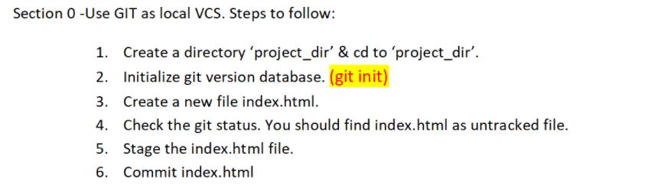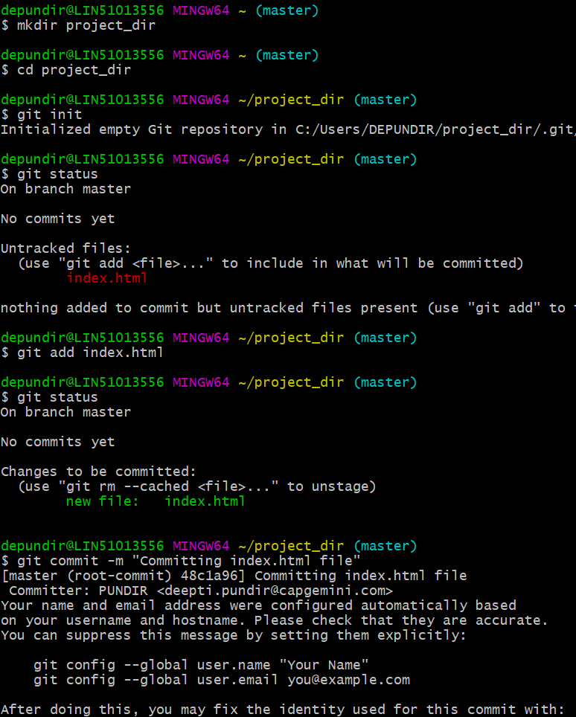



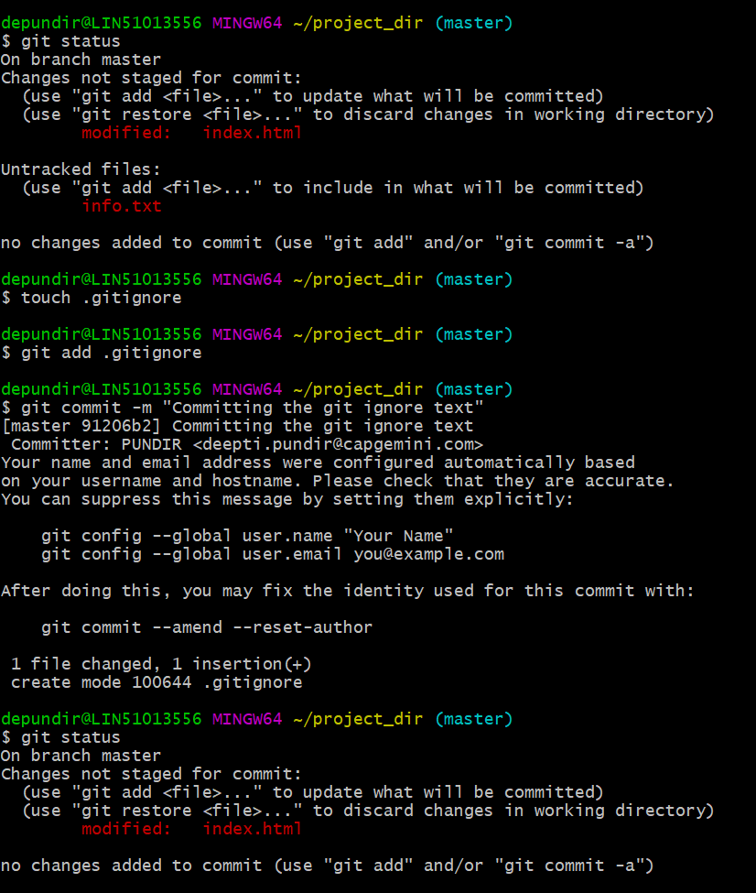

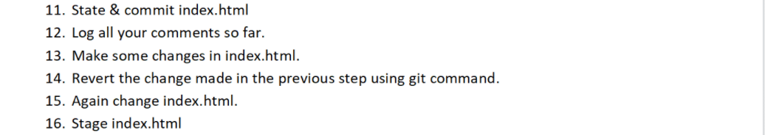

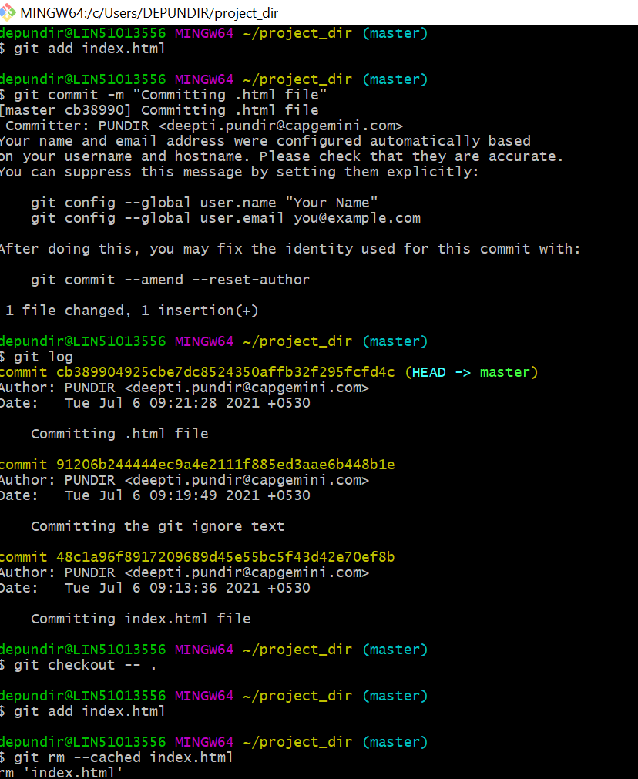

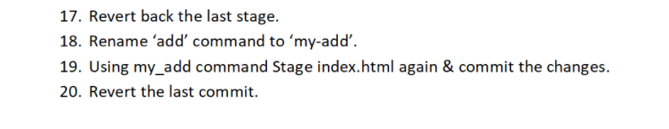

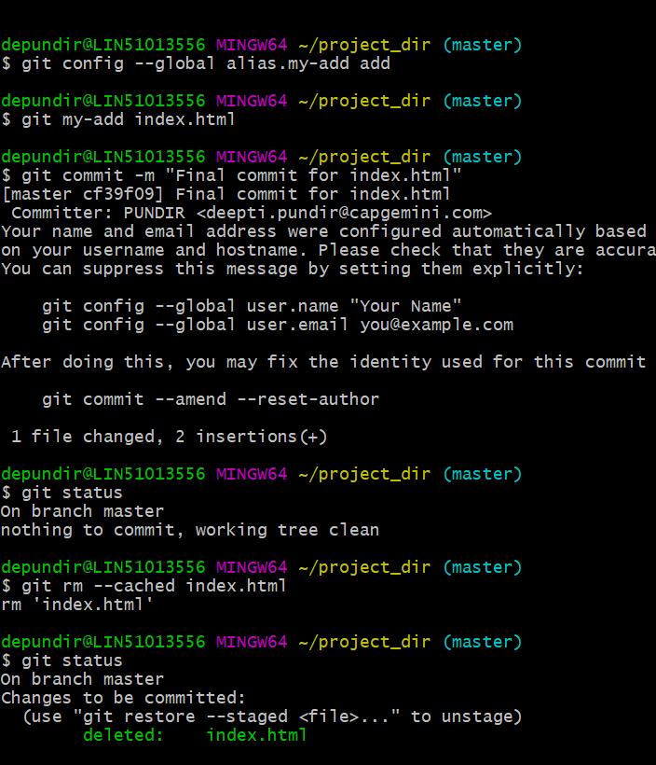

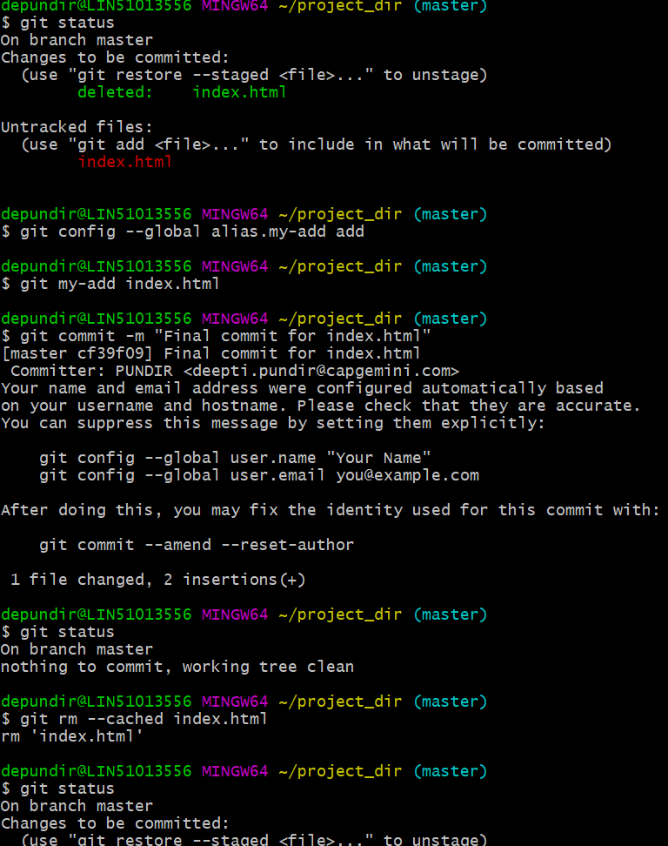

**Section 1**

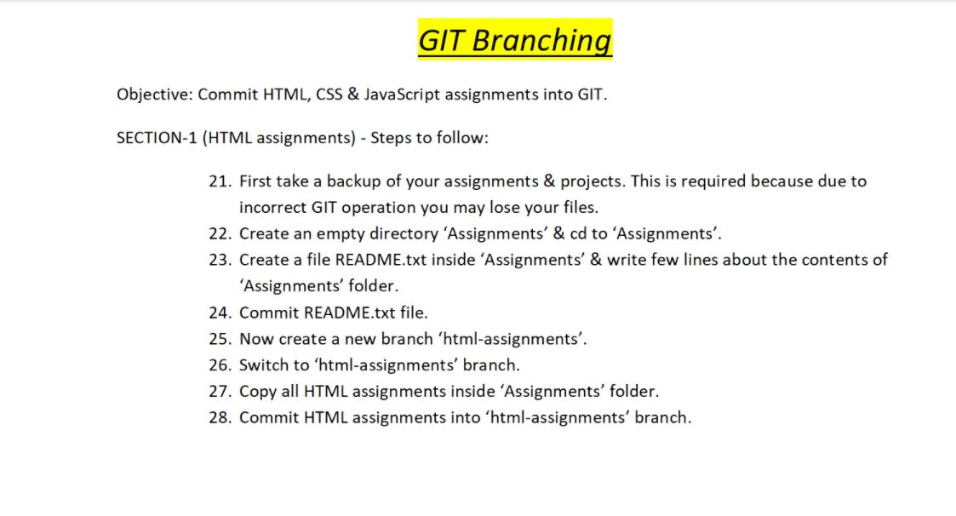

21. mkdir assignments

22. cd assignments

22.1. touch readme.txt

22.2. vi readme.txt -> press i -> (edit file) Starting the assignment -> esc -> :wq!

24. git add readme.txt ; git commit –m “commit readme text file”

25. git branch html-assignments

26. git checkout html-assignments

27. vi readme.txt -> press i -> (edit file) 1. create a new branch -> esc -> :wq!

28. git add readme.txt ; git commit –m “edited text file in html branch”

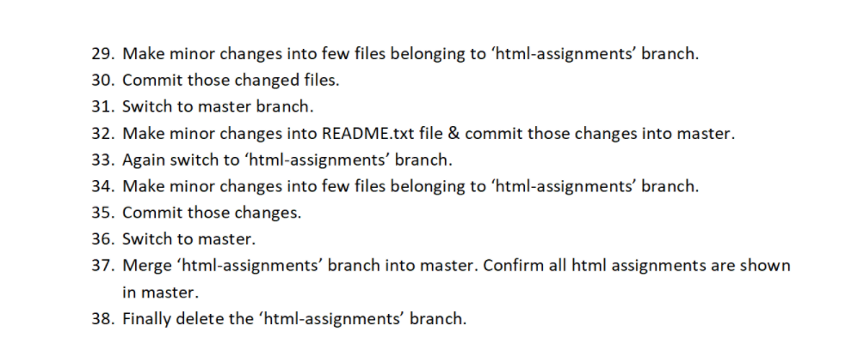

29. vi readme.txt -> press i -> (edit again) 2.html-assignment -> esc -> :wq!

30. git add readme.txt ; git commit –m “minor changes while in html branch”

31. git checkout master

32. vi readme.txt -> press i -> (edit again) started branching -> esc -> :wq!

32.1. git add readme.txt ; git commit –m “commiting changes of master branch”

33. git checkout html-assignments

34. vi readme.txt -> press i -> (edit again) 3. New branch successfully created -> esc->:wq!

35. git add readme.txt ; git commit –m “commiting changes”

36. git checkout master

37. git merge html-assignments

38. git branch –d html-assignments

**Section 2**

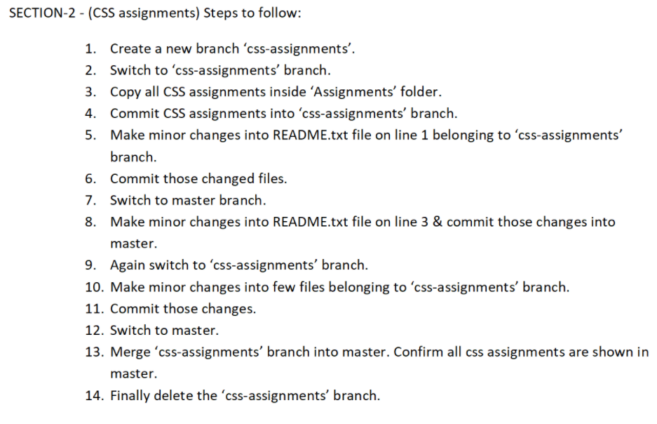

1. git branch css-assignments
2. git checkout css-assignments
3. vi readme.txt -> press I -> copy assignment -> esc -> :wq!
4. git add readme.txt ; git commit –m “css first commit”
5. vi readme.txt -> press I -> copy assignment - 1. A new branch is created-> esc -> :wq!
6. git add readme.txt ; git commit –m “css second commit”
7. git checkout master
8. vi readme.txt -> press I -> copy assignment - and start -> esc -> :wq!
9. git add readme.txt ; git commit –m “master commit”
10. git checkout css-assignments
11. vi readme.txt -> press I -> copy assignment 1. A new branch is created - and commited-> esc -> :wq!
12. git add readme.txt ; git commit –m “css third commit”
13. git checkout master
14. git merge css-assignments
15. Git branch –d css-assignments

**Section 3**

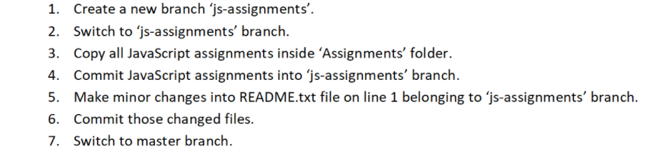

1. git branch js-assignments
2. git checkout js-assignments
3. vi readme.txt -> press I -> copy js-assignment-> esc -> :wq!
4. git add readme.txt ; git commit –m “js first commit”
5. vi readme.txt -> press I -> copy js-assignment - start-> esc -> :wq!
6. git add readme.txt ; git commit –m “js second commit”
7. git checkout master

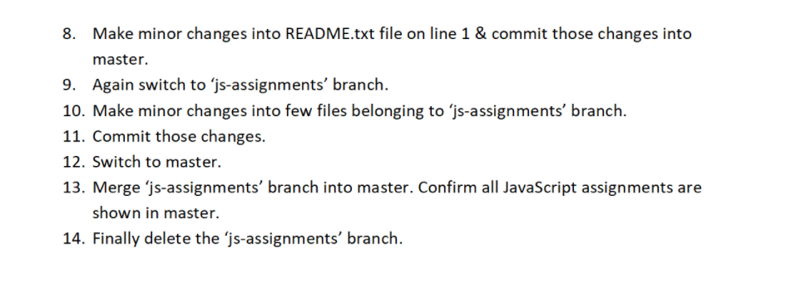

1. vi readme.txt -> press I -> Starting the assignment - js -> esc -> :wq!
2. git checkout js-assignments
3. vi readme.txt -> press I -> copy js-assignment start - editing -> esc -> :wq!
4. git add readme.txt ; git commit –m “js second commit”
5. git checkout master
6. git merge js-assignments
7. Git branch –d js-assignments

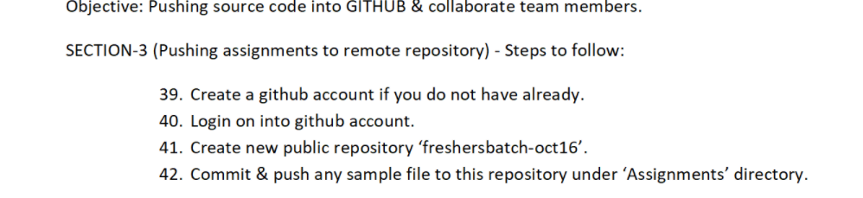

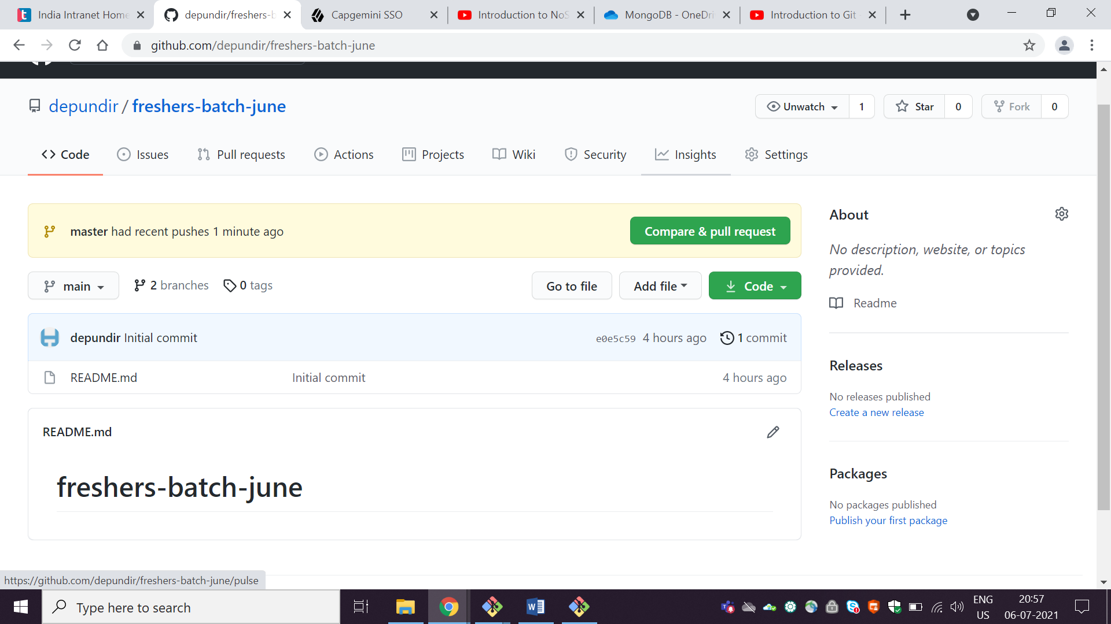

**Section 4**



